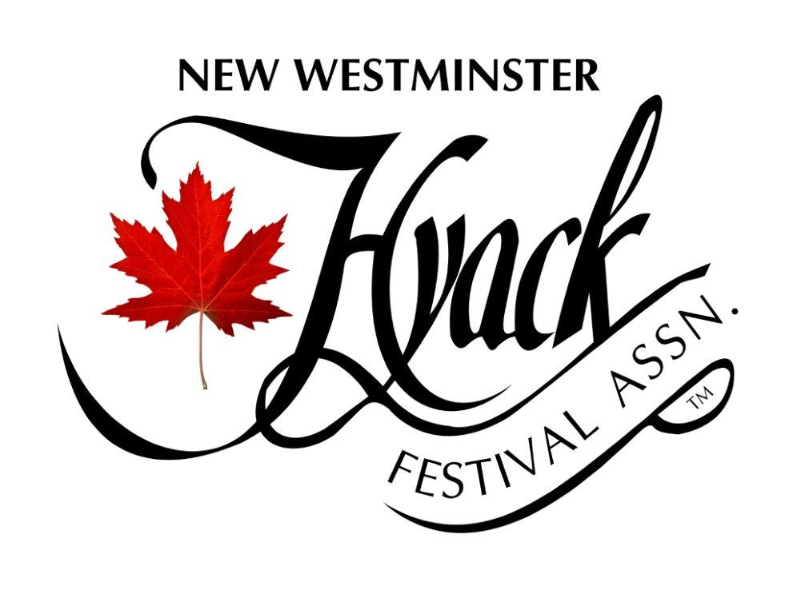

Application Process

- Download and complete application - deadline for application is June 1, 2022 at 4 pm delivered to Hyack Festival Association office.
- First interview with Applicant to review program commitment, scheduled any time after we receive application up till August 1.
- Next level Applicants will have second interview WITH Parent, and review legal contract, by end of August 2022.
- Medical report due upon completion of second interview.
- Successful Applicants will be notified/invited to program by end of August 2022 and Leadership Training will begin September 2022.
- Successful CANDIDATES should have Nexus, if not, apply ASAP as Ambassadors cannot travel to USA without one.

204 Sixth Street, New Westminster, BC V3L 3A1 | 604-522-6894 | hyackfestival.com/

NEW WESTMINSTER HYACK AMBASSADOR LEADERSHIP PROGRAM 2023

Included in this package are the following:
- Introduction (2 pages)
- Application Form (3 pages)
- Rules and Regulations (2 pages)
- Code of Conduct Form (2 pages)
- Parent Consent Form (2 pages)
- Medical Form (separate from this package, 4 pages)

ONLY Completed Application Packages will be contacted for interview and must include:
- Official Application Form
- 2 Essays
- Photograph
- Proof of Age (copy of birth certificate or driver’s license)
- Copy of page 2 of your Passport
- 2 Letters of Reference (not family member)
- Signed Code of Conduct
- Signed Parent Consent Form
- Completed and Signed Medical Form (upon second interview)

Application deadline: 4 pm on June 1, 2022 to Hyack Office at 204 Sixth Street
If you have any questions regarding any of the enclosed information, please contact the Hyack Office at 604-522-6894 or program coordinator, Deb Wardle at 604-802-2402

NEW WESTMINSTER HYACK AMBASSADOR LEADERSHIP PROGRAM 2023 Introduction for Applicants and Parents

Ambassador: “An authorized messenger or representative sent by one Festival/City to another to represent and promote one’s own city in a professional, courteous and friendly manner.” You will be selected, and trained, by the Hyack Festival Association to do this job.
Training: The Hyack Ambassador Leadership Program is a self-development program for young women ages 16 to 19. It has been transforming the lives of New Westminster youth for 45 years. From September 2022 to the Awards Gala in mid-April 2023, the mandatory Tuesday Night Training (TNT) mentoring sessions (6:30 pm – 8:30 pm) cover topics such as speech craft, financial planning, self defense, history of New Westminster, leadership, deportment and business skills. TNT continues after the Awards Gala (bi-monthly) till June, attendance is still mandatory.
Judging: There are several judged events leading up to the “Evening of Stars” Awards Gala including the President’s Tea, Etiquette Dinner, Judges’ Personal Interviews, Talent/Speech Night, Gala Evening and Committee mark on participation and attendance.
Time: The time commitment is extensive and often a challenge. However, accepted Candidates who participate in the Tuesday Night Training (TNT) sessions, and ultimately the Leadership Program, make long lasting friendships, enhance their resume, obtain required graduation volunteer hours, have the opportunity to win scholarships and develop skills that will enhance their confidence and abilities which last a lifetime. Please evaluate your availability to accommodate this commitment.
Chaperones: At all Hyack Festival sanctioned events/parades, locally or out-of-town, the Candidates/Ambassadors are chaperoned by at least one responsible female adult who has had a criminal record check and has been screened by the Hyack Ambassador Committee.
Clothing: A new wardrobe is not necessary, however, you will be required to have your own floor length formal gown for the Awards Gala and special events. Some guidelines are required for gowns, so please consult the committee prior to making a purchase as some styles are not appropriate for this program. Dress/suit, pants, tops, black shoes, sashes/tiaras are provided.

Page 1 of 2

Scholarships: At the end of your Ambassadorial year (when you retire) you will receive your Hyack Post-Secondary Scholarship, upon proof of registration at a post-secondary institution of higher learning. Scholarships are not automatic but must be earned; you are doing a job for Hyack. Amount of scholarship is dependent upon attendance, participation, and attitude throughout the year. Additional Ambassador Awards are announced and awarded at the Gala.
Parent Participation: Everyone is expected to participate, through fundraising, chaperoning (locally) and supporting your youth.
Fundraising: Everyone is expected to participate. This is an important part of our program and travel to other BC Awards Galas depends on it. Hyack will pay for out-of-town travel to parades (where float is entered) that are associated with Pacific Northwest Hosting, but BC gala weekends we decide to attend, are extra. A spreadsheet is kept to keep track of who participates and this assists committee on which Ambassadors will be eligible to attend these extra events.
ALL Hyack Ambassadors are expected to participate in the year’s activities (fundraising, travel, parades etc), not just the title winners. We are one of only three programs in all of BC (over 20 provincial programs) that install ALL candidates as members of the New Westminster Hyack Leadership Team and keep everyone involved ALL year!
This program requires a lot of work and dedication, but the skills that are learned will last a lifetime. The program is committed to assisting Candidates/Ambassadors perform well in school as well as in the program. If you have any questions or concerns about the time commitment, please contact a committee member and we can discuss the Program with you.

COMMITTEE MEMBERS:
Becci Dewinetz 604-230-1044 Karen Davidson 604-786-6654
Deb Wardle 604-802-2402 Julia Mercer 709-683-1626
Sherry Joel 604-522-8477 Penny McIvor 604-312-3696
Carla Brown 604-524-2695 Alyssa Quan 778-866-6415
Lisa Falbo 604-729-9352 Leslie Ducommun 778-792-0052

Page 2 of 2
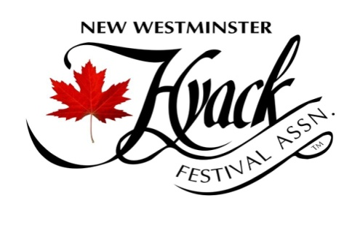

NEW WESTMINSTER HYACK AMBASSADOR LEADERSHIP PROGRAM 2023
Official Application Form
I, _____________________________________ hereby enter the Hyack Ambassador Program.
I have read and agree to abide by the Rules and Regulations of the Hyack Ambassador Program, now in effect, and I will abide by such other additional or amended rules and regulations, which may hereinafter be declared by the Hyack Festival Association and their decision shall be final.
I agree that, as a Candidate/Ambassador of the program, I will not sign a management contract with any individual or corporation and I will not give any written consent or verbal endorsement of any mercantile commodity or commercial organization, nor will I permit my photograph to be used in connection with any advertised commodity or service not associated with the Hyack Festival Association without prior written permission from the Hyack Festival Association.
Name: _______________________________________________________________________
Address: ___________________________________________________PC:________________
Telephone (home) _____________ Cell ____________ Email ___________________________
Birth date: ____________ Birthplace: __________________________ SIN: _______________
Eye Colour: ______________ Hair Colour: ______________ Height: ___________________
Number of years living in New Westminster: ________ Other languages: __________________
School: _______________________ Location: ______________________________________
Are you currently employed? ___ Y ___N ___Full time ____Part time
Name of Business: _____________________________________________________________

Page 1 of 3

Please describe your Interests Hobbies, Volunteer Work, Clubs, and Organizations etc.
_________________________________________________________________________________________________________________________________________________________________________________________________________________________________________________________________________________________________________________________________________________________________________________________________

Sports and Teams
_________________________________________________________________________________________________________________________________________________________________________________________________________________________________________________________________________________________________________________________________________________________________________________________________
Special Training (Dance, Music, Art, Karate etc.)
_________________________________________________________________________________________________________________________________________________________________________________________________________________________________________________________________________________________________________________________________________________________________________________________________

Future Plans, Career Choices and Why
_________________________________________________________________________________________________________________________________________________________________________________________________________________________________________________________________________________________________________________________________________________________________________________________________

SUBMIT AN ESSAY (500 TO 700 WORDS) ON EACH OF THE FOLLOWING 2 QUESTIONS:

What qualities/attributes do you think would be necessary to be a successful Ambassador?
As a young person in today’s Royal City, in your opinion, what is New Westminster’s biggest challenge and what can you do about/or for it?
Page 2 of 3

I ATTEST THE ABOVE INFORMATION TO BE TRUE AND CORRECT
Signature of Candidate: _____________________________________ Date: ______________
Signature of Parent/Guardian: ____________________________________________________
Print Name of Parent/Guardian: __________________________________________________
Address of Parent/Guardian: ________________________________________PC___________
Parent/Guardian Phone Number: ______________ Email: ______________________________
Signature of Parent/Guardian: ____________________________________________________
Print Name of Parent/Guardian: __________________________________________________
Address of Parent/Guardian: ________________________________________PC___________
Parent/Guardian Phone Number: ______________ Email: ______________________________
Signature of Witness: ___________________________________________________________
Print Name of Witness: __________________________________________________________

ALONG WITH THIS COMPLETED APPLICATION FORM, PLEASE ATTACH/SUBMIT:
- PHOTOGRAPH OF YOURSELF
- PROOF OF AGE, (copy of Birth Certificate or Drivers License)
- PASSPORT (copy page 2 only)
- 2 LETTERS OF REFERENCE (NOT FAMILY OR FRIENDS)
- YOUR TWO ESSAYS
- SIGNED CODE OF CONDUCT FORM
- SIGNED PARENTAL CONSENT FORM
- SIGNED DOCTOR’S MEDICAL FORM (can be submitted upon second interview)

PLEASE SUBMIT TO HYACK OFFICE (204 SIXTH STREET) BY 4 PM, June 1, 2022

Page 3 of 3

NEW WESTMINSTER HYACK AMBASSADOR LEADERSHIP PROGRAM 2023
Rules and Regulations
- Candidate must be a resident of New Westminster for 6 months preceding September 1, 2022 and for duration of program.
- Candidates must be attending school and have reached their 16th birthday by December 31 of the current year and not be older than 19 by September 1st of the year of the application. A copy of the Candidate’s birth certificate must accompany the application.
- Candidates must be of good character and not have a criminal record.
- Candidates must be of good health during the period of this program. If applicable, Candidates must submit a doctor’s certificate approving participation, along with the prescribed treatment, must obtain their own travel insurance and if necessary be accompanied on out-of-town travel by their parent/guardian.
- All Candidates must sign the Code of Conduct.
- Candidates may be disqualified if their qualifications are found to be in contravention of any of the program regulations. Candidates may also be disqualified if they fail to observe any of the instructions or regulations which may be set out by the chaperones, supervising officials, or their individual sponsor during their time in the program.
- Candidates will be judged on these occasions: 1) President’s Tea and Sponsor’s Speech, 2) Etiquette Dinner, 3) Individual Judges Interviews, 4) Talent and 2nd speech, 5) Committee on attendance/participation, and 6) Awards Gala evening. The Judges’ marks will decide the title recipients on the basis of public speaking ability, community knowledge, community involvement, essays, knowledge of the Hyack Festival Association, personality and presentation. The decision of the Judges shall be final.
- Candidates/Ambassadors pictures will be used by the Hyack Festival Association for promotional advertising including newspaper, posters, Hyack website, Facebook etc.

Page 1 of 2

- The Hyack Ambassador Program will provide the official clothing (except formal wear), sash, name tag and team tiara. If any of these items are lost, stolen or damaged, it is the responsibility of the Candidate/Ambassador to replace the items at their own expense. Sashes and Tiaras are $60.00 each and name badges are $15.00 each.
- Schoolwork, social engagements, or work are not acceptable excuses for being absent from the mandatory mentoring (TNT) classes or scheduled Hyack engagements, please plan your schedule accordingly. If you are unable to attend, you personally must contact the Coordinator. Unexcused absences will result in point deductions by the Judges.
- Candidates/Ambassadors are not permitted, under any circumstances, to approach their sponsor for additional funds that may be incurred during the program.
- The Coordinator must be notified if a Candidate/Ambassador has been requested to attend a sponsor function. The Candidate/Ambassador or their parents may not give permission to attend any function. All requests for Candidate/Ambassador appearances go through the Hyack Office, and a Hyack Chaperone will be assigned.
- All Candidates/Ambassadors will be required to attend sponsor’s functions, however, the Candidate/Ambassador whose sponsor is putting on the event, will act as hostess.
- Cell phones are not to be used during TNT classes, public events or parades. Phones will be held by appointed chaperones during events.
- For the Awards Gala weekend, Candidates will be given tickets to sell. These tickets are the sole responsibility of the Candidates. The Candidate will be responsible for paying back the amount of tickets if lost or stolen.
- All Candidates/Ambassadors are required to take part in fundraising activities as set out by the Committee, this is mandatory.
- If for any reason a Candidate/Ambassador leaves the program for other than a legitimate medical reason (letter from physician required), the Candidate/Ambassador, and/or her family, is solely responsible for repaying the sponsor’s full sponsorship fee of $1000.00.

FAILURE TO COMPLY WITH THESE RULES AND REGULATIONS MAY RESULT IN A REVIEW OF YOUR POSITION, WHICH MAY RESULT IN THE DISQUALIFICATION OF YOUR CANDIDACY/AMBASSADORSHIP AND THE REIMBIRSEMENT OF SPONSORSHIP FEE TO BE RE-PAID BY CANDIDATE/AMBASSADOR.

Page 2 of 2

NEW WESTMINSTER HYACK AMBASSADOR LEADERSHIP PROGRAM 2023
Code of Conduct
As a New Westminster Hyack Ambassador, you will be asked to appear at numerous functions, parades and events where you will be in the spotlight and others will constantly be watching you. Hyack’s Board of Directors, our community, aspiring Ambassadors, reigning and past Ambassadors and your peers, will notice you. Being on your best behavior AT ALL TIMES is a must; even if you are not dressed in your Hyack attire you are still our City Representative and must carry yourself accordingly.
I, ___________________________________ will endorse and promote the following goals while representing the Hyack Festival Association and the Hyack Ambassador Program. I will:
- Show respect to chaperones, sponsors, other ambassadors, the public and myself.
- Behave in an appropriate manner. I will maintain standards of exemplary conduct and will not act in any way in my public or private life (including social media) which will, in the opinion of the Hyack Festival Association, interfere with my duties as a Hyack Candidate/Ambassador or will bring discredit upon the Hyack Festival Association or the City of New Westminster. This includes, but not limited to, drinking alcoholic beverages, using illegal substances, chewing gum or smoking in public while in my role as a Candidate/ Ambassador.
- Use social media sites with discretion when posting photos, comments, etc. and not to use the Internet in an illegal or inappropriate manner. The Committee has the right to request taking something off my site at any time and I will comply with request.
- As a Candidate/Ambassador, conduct myself in an appropriate manner at all functions either private or public with grace, respect, poise, dignity and a cheerful, positive attitude.
- Not wear the official clothing, shoes, sash or tiara at any time (or let anyone else wear sash and tiara) except when instructed by the Coordinator for sanctioned Hyack events.

Page 1 of 2

- While in the program representing Hyack, to not show any public display of affection (PDA) to my fellow Ambassadors and/or personal friends. I will explain to friends and family that they must respect my role and allow me to do my job with utmost decorum.
- Dress appropriately for all program related events. This includes no major changes in hair colour or style (committee must approve, in advance, any hair colour/style changes), thin strap tank tops, visible tattoos will need to be covered, and removal of tongue and facial piercings when representing Hyack.
- Remember that manners are important, “nice” words are always appropriate and to say please and thank you. I will send/deliver thank you cards to anyone who has helped me.
- Remember my table manners and never chew gum when in tiara and sash.
- Never engage in any behavior that could be considered bullying or harassment to my fellow Ambassador teammates.

Integrity – I recognize the support of the Hyack Festival Association, my sponsor, and my family as a symbol of public faith, and accept that faith as a public trust, which demands integrity in all that I do.
Cooperation - I recognize the value of cooperation, and stand committed to work with other organizations and the public to achieve results that provide a common benefit to all.
Leadership & Respect – I recognize the importance of respect in my dealing with all people, and shall demonstrate an unfailing commitment to the fair treatment of all individuals without regard to gender, religion, sexual orientation, culture, age or race.
Community & Accountability - I recognize the necessity of high-performance standards and will strive to maintain a degree of excellence in the performance of my duties that ensures public confidence. I will strive to communicate effectively in all I do.

Signed: _________________________________________ Date: ____________________

Witness: ________________________________________ Date: ____________________

Page 2 of 2

NEW WESTMINSTER HYACK AMBASSADOR LEADERSHIP PROGRAM 2023
Parent Consent Form
I/We,________________________________________________________________________ have read the Rules and Regulations of the Hyack Ambassador Leadership Program and along with my/our child, will abide by them and by such other additional or amended rules and regulations which may hereinafter be declared by the Hyack Festival Association.
I/We herby agree that the time, manner, and method of judging shall be solely within the discretion of the Hyack Festival Association and that the decision of the Judges shall be final.
I/We agree that, as a Hyack Ambassador, I will not allow my child to sign a management contract with any individual or corporation and I/we will not give any written or verbal endorsement of any mercantile commodity or commercial organization, nor will I/we permit my child’s photograph to be used in connection with any advertised commodity or service not associated with this program without prior written permission from the Hyack Festival Association.
If at any time, my child is unable to fulfill their commitment to the Hyack Ambassador Leadership Program in anyway, or withdraws prior to the completion of their year, I/we agree to be responsible for returning the full $1000.00 sponsorship fee. I/We agree to pay this fee in full upon request of the Hyack Festival Association.
I/We understand that the Hyack Festival Association and Hyack Ambassador Program committee will not be responsible for chaperoning Candidates to and from the regular Tuesday Night Training (TNT) mentoring sessions. Candidates are encouraged to arrange car pools. However, no one will be allowed to leave evening TNT sessions unescorted. If anyone needs a ride home, it is candidate’s responsibility to secure a committee member to drive them home.
Parents/Guardians “may” be invited by the Hyack Festival Association to chaperone “some” of the local events attended by the Candidates/Ambassadors.

Page 1 of 2

I/We hereby give my/our permission to allow my/our child to participate in the Hyack Ambassador Leadership Program 2023.

Date: ___________________________

Candidate’s Name:_____________________________________________________________

Signature of Parent: ____________________________________________________________
Print name:___________________________________________________________________
Signature of Parent: ____________________________________________________________
Print name: ___________________________________________________________________

Signature of witness: ___________________________________________________________
Print name: ___________________________________________________________________

Page 2 of 2

